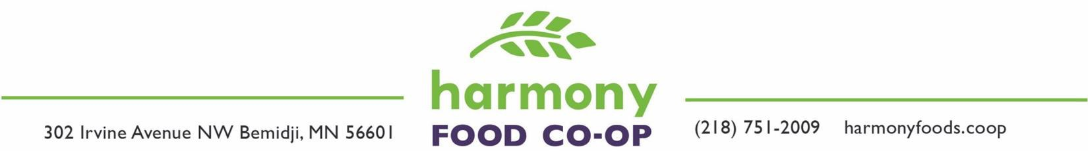

Board of Director Vacancies

SELF-NOMINATION FORM
Nomination Deadline: January 31st, 2024

Date Name Address | Phone  E-mail Preferred method, if we need to contact you:  E-mail; Phone; Mail

Candidate Statements
(These statements will be provided to Owners in the spring newsletter and on the Harmony website.)

- Describe your background and what kinds of technical and community knowledge you would bring to the board:

- What's your experience with open communication, group process and decision making?

- What areas of growth, development and ongoing success do you see for Harmony's future?

References
Please provide names and contact information for two references who are member/owners of Harmony:

Name:  Address:  Phone:  E-mail, if available: | Name: Address: Phone:  E-mail, if available:

Submit Form
Deadline: January 31st, 2024

There are three ways to submit this form:
  - Drop it off at the co-op.
  - Mail it to Board of Directors, Harmony Co-op, 302 Irvine Ave NW, Bemidji, MN 56601.
  - E-mail it to boardofdirectors@harmonyfoods.coop. You may include the content (does not have to be the form) in the e-mail body or send the form as a Word, Text, or .PDF attachment.

Additional Information
- Harmony Mission: To serve the common health of our community. We are committed to the application of co-op principles, community education and to providing whole and healthy foods and other goods which support a sustainable environment.
- Candidates for the Board of Directors are self-nominated and are elected by a vote of the membership. Terms run for three years.
- The Board of Directors meets once a month, usually from 6:00 - 8:00 PM on the last Wednesday of the
month. Per Harmony’s Articles of Incorporation, “The government of this association and the
management of its affairs shall be vested in a Board of Directors.”
- Harmony operates under Policy Governance. Visit the Board of Directors' page
< www.harmonyfoods.coop/boardofdirectors > on the Harmony website for additional information, including links to policies, related documents (scroll down to the lower right, under Board Links), and an information piece on “What is Policy Governance.”
- If you have questions about serving on the Board, please contact a current Board member: www.harmonyfoods.coop/boardofdirectors

