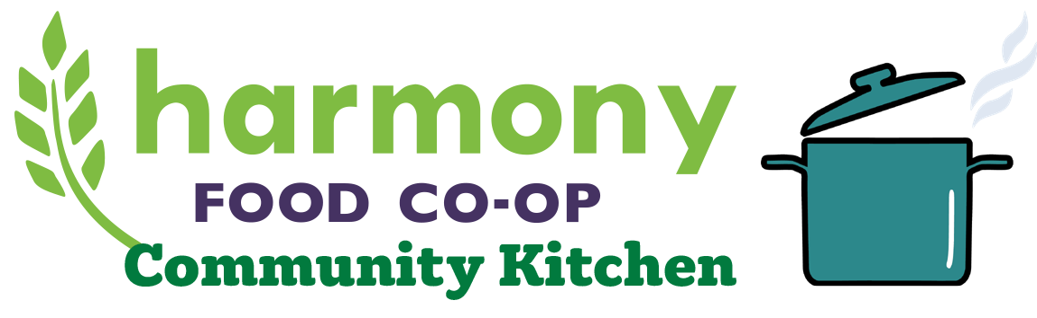
Community Kitchen Donation Request
One of Harmony’s self-defined roles in this region is to “provide access to educational opportunities about the benefits of locally and organically sourced products, cooperative principles, and nutritious eating”. Therefore, Harmony will donate a budgeted amount of Kitchen hours annually to applicants who will be using the kitchen in a manner not for profit or for personal benefit, and who meet TWO of the following criteria:
- Local: Serves the North Central Minnesota Area
- Co-ops: Promoting Co-operatives of any kind
- Health: Promotes Fitness, Good Nutrition, or Disease Prevention
- Community: Assists in community wellness through education, non-profit fundraising, and community support.
- Dealing with Food Issues: Hunger, Food Safety, Environmental Protection, Sustainable Agriculture Promotion.
- Member-Owner: You have invested in our Co-operative as a Member-Owner.
Please Note: We receive daily requests for donations from a wide range of organizations, causes and events. We would love to be able to donate Kitchen time to everyone who asks, but we are a cooperative business owned by our members so we have a responsibility to spend their investment wisely to benefit the community.

Name of Organization: _________________________________ Date: __________________
Contact Person: _____________________________________________________________
E-mail: ______________________________ Phone: ______________________________
Date and Timeframe of Kitchen Use Requested: ___________________________________

Description of Event including number of people who will be in attendance: ______________________________________________________________________________
____________________________________________________________________________________________________________________________________________________________
______________________________________________________________________________
______________________________________________________________________________
Description of equipment you’ll be using, including numbers of tables and chairs:
_______________________________________________________________________________________________________________________________________________________________________________________________________________________________________________________________________________________________________________________

Has Harmony Co-op donated to your organization in the past? If so, when?
__________________________________________________________________________
Will you be recognizing us as a donor in some way?
__________________________________________________________________________
Please submit form to the customer service counter or the education desk attention: Lisa W.
Thank you for your request. We will be in touch with your organization via email within 7 days of your donation request.
For more information on the various uses of the Kitchen, contact Lisa Weiskopf at 218.751.2009 ext. 111 or email productmanager@harmonyfoods.coop. You can also find us on the web at www.harmonyfoods.coop/communitykitchen/.

